Jamie Butts
End of Summer FURSCA Report
This summer, my advisor, Dr. Jerry Fisher, and I researched and experimented on how caffeine affects our memory, specifically recall and recognition. 16 participants were gathered from Albion College and were asked to participate. Half of these participants were given decaffeinated coffee, while the others received caffeinated coffee. They were then asked to read 2 ambiguous stories and answer recognition-based questions. We then analyzed the results to determine if the caffeinated group performed better than the decaffeinated group on the memory task. Our secondary research question was whether caffeine affects our perceived danger of a situation. At the end of the memory task, individuals were asked to rate each story's danger on a scale of 1-7.
Our results showed no significant difference between our caffeinated and decaffeinated groups. The accuracy difference between the two groups was 3% and the perceived danger difference was 0.07. We did find a bigger, but still insignificant, difference between those who thought they had caffeinated coffee and those who thought they had decaffeinated coffee. The participants who believed that they had caffeine performed 6% higher and had a 0.27 lower perceived danger score than those who believed that they did not have caffeine. These results did not support our hypothesis of caffeine enhancing memory and increasing perceived danger of a situation.
These results were limited by sample size, time of day, and difference in sugar amounts. Our sample size was smaller than our preferred number of 24 participants. Having a larger sample size is a better representation of a population and can have more accurate results. This experiment was conducted early in the morning every weekday, which can influence people’s ability to retain information. Participants were allowed to add sweetener, sugar, and creamer to their coffee. Sugar is another stimulant that could alter the results as well, limiting the accuracy of this study.
This study is important due to its difference in memoranda from past research. Other studies have used a form of word lists for the participants to memorize, whereas we used stories. Stories use a different pattern of retention from word lists due to their different contents. This contributes a new perspective on the effects of caffeine on memory. Personally, this experiment has taught me how to navigate issues that come up during an experiment and how to conduct one professionally. In the future, I plan to present my method and findings at the Elkin Issac Symposium at Albion College next year. I would like to thank Dr. Jerry Fisher, Dr. Drew Christopher, and my finance donor for supporting and assisting me through this process.
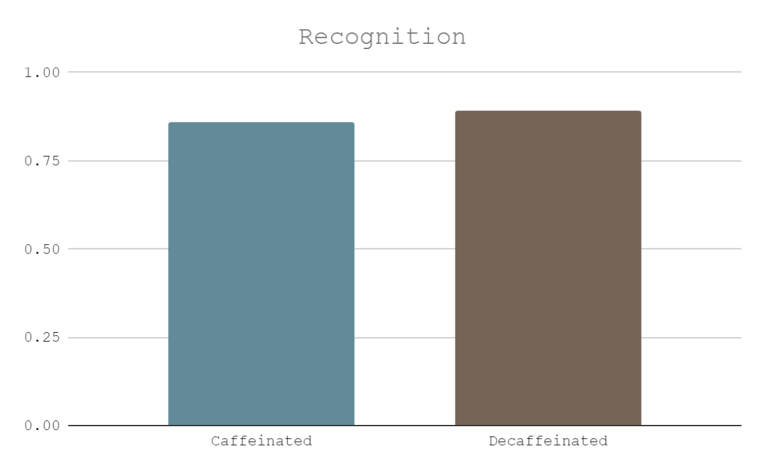
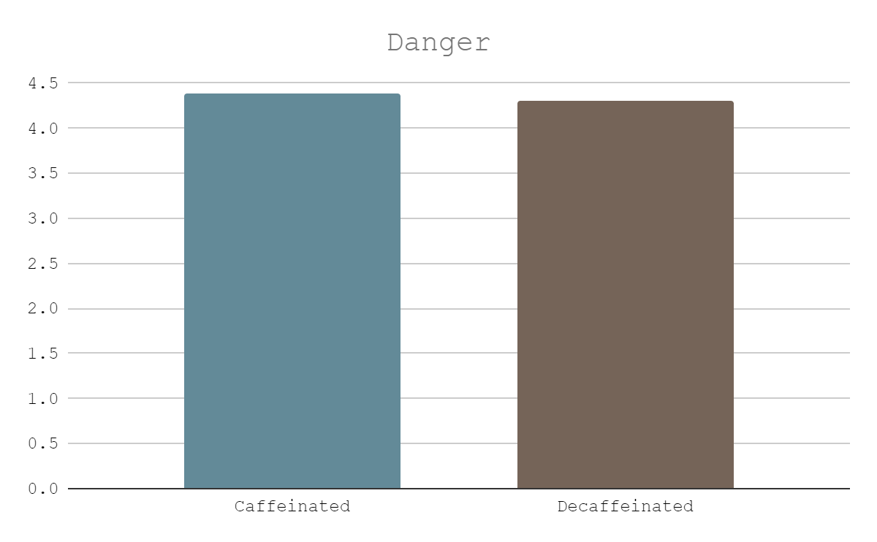
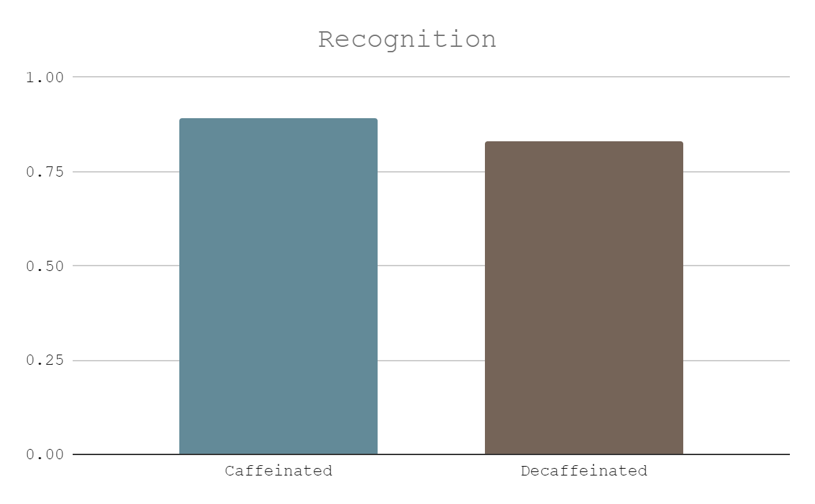Placebo Effect
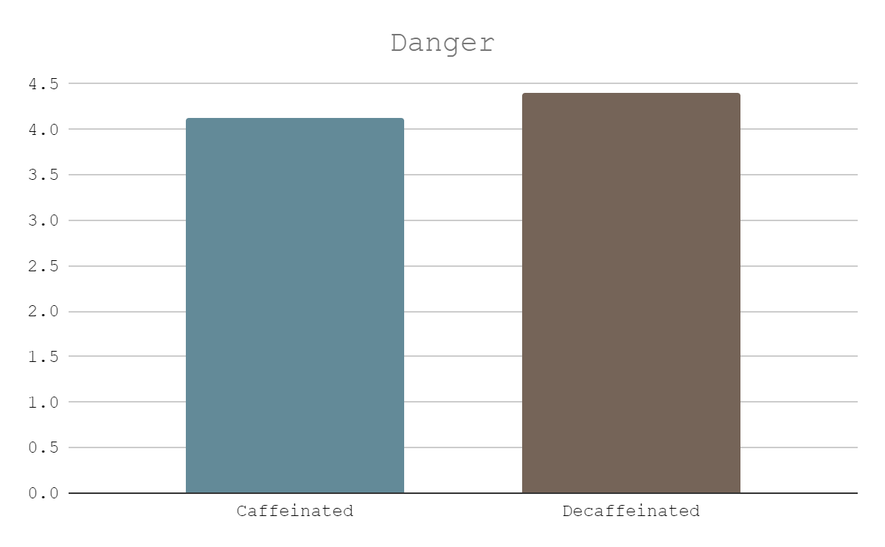Placebo Effect

